**DBMS LAB 6**

**PROGRAM 6: ORDER DATABASE**

Consider the following schema for Order Database:  
  
SALESMAN (*Salesman_id,Name, City, Commission*)  
CUSTOMER (*Customer_id,Cust_Name, City, Grade, Salesman_id*)  
ORDERS (*Ord_No,Purchase_Amt, Ord_Date, Customer_id, Salesman_id*)

CREATE DATABASE ORDER;

CREATE TABLE SALESMAN (SALESMAN_ID int,

NAME VARCHAR (20),

CITY VARCHAR (20),

COMMISSION VARCHAR (20), PRIMARY KEY (SALESMAN_ID));

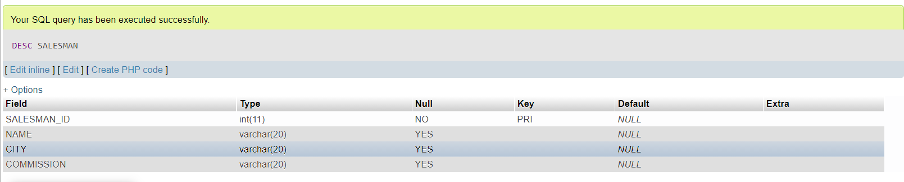

CREATE TABLE CUSTOMER (CUSTOMER_ID INT, CUST_NAME VARCHAR (20),

CITY VARCHAR (20),

GRADE INT (3), SALESMAN_ID int,

PRIMARY KEY (CUSTOMER_ID),

FOREIGN KEY (SALESMAN_ID) REFERENCES SALESMAN (SALESMAN_ID) ON DELETE SET NULL);

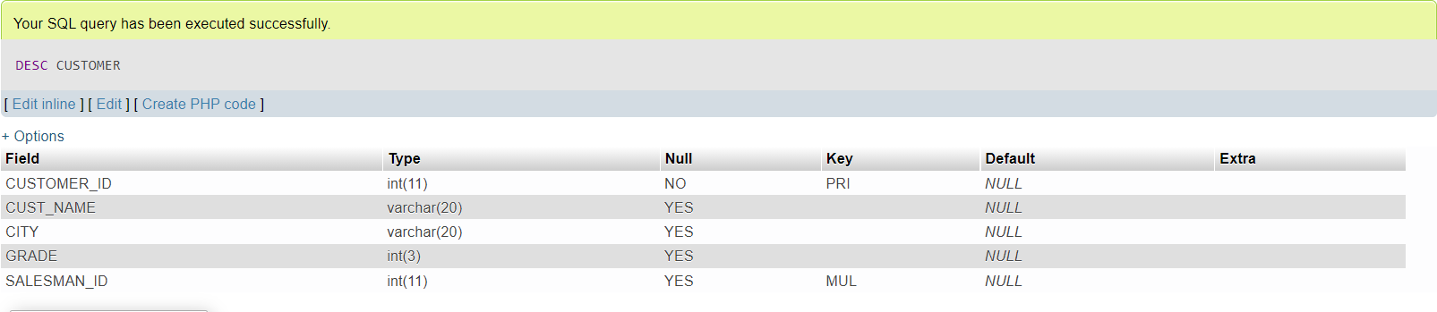

CREATE TABLE ORDERS (ORD_NO INT, PURCHASE_AMT INT, ORD_DATE DATE, CUSTOMER_ID INT, SALESMAN_ID INT, PRIMARY KEY (ORD_NO),

FOREIGN KEY (CUSTOMER_ID) REFERENCES CUSTOMER (CUSTOMER_ID) ON DELETE CASCADE, FOREIGN KEY (SALESMAN_ID) REFERENCES SALESMAN (SALESMAN_ID) ON DELETE CASCADE);

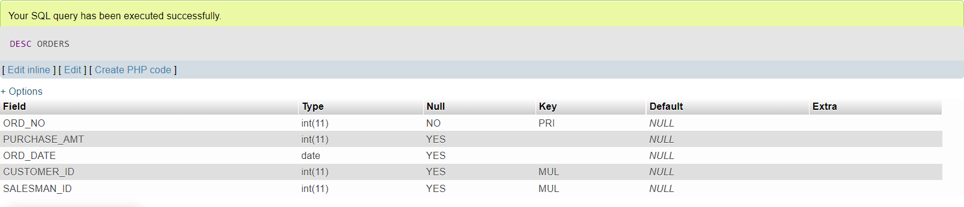

INSERT INTO SALESMAN VALUES (1000, 'JOHN','BANGALORE','25 %'), (2000, 'RAVI','BANGALORE','20 %'),

(3000, 'KUMAR','MYSORE','15 %'),

(4000, 'SMITH','DELHI','30 %'),

(5000, 'HARSHA','HYDRABAD','15%');

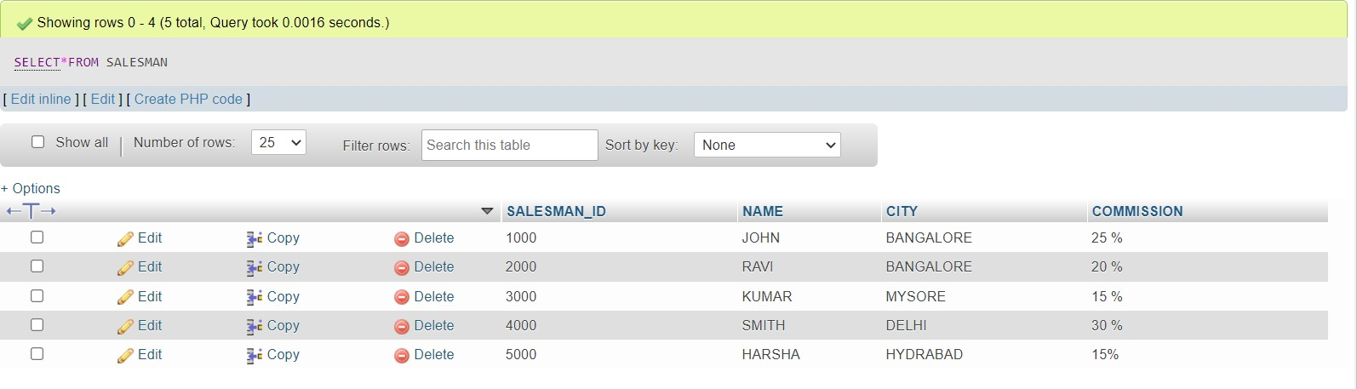

INSERT INTO CUSTOMER VALUES (10, 'PREETHI','BANGALORE', 100, 1000),

(11, 'VIVEK','MANGALORE', 300, 1000),

(12, 'BHASKAR','CHENNAI', 400, 2000),

(13, 'CHETHAN','BANGALORE', 200, 2000),

(14, 'MAMATHA','BANGALORE', 400, 3000);

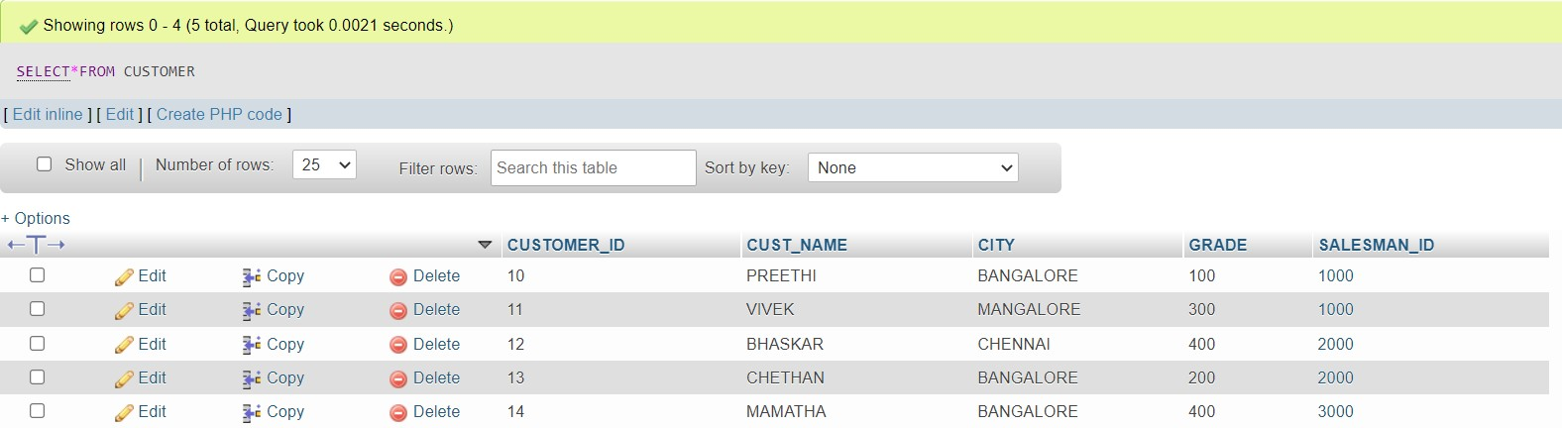

INSERT INTO ORDERS VALUES (50, 5000, '2017-04-04', 10, 1000),

(51, 450, '20-JAN-17', 10, 2000),

(52,1000,'24-FEB-17',13,2000),

(53,3500,'13-APR-17',14,3000),

(54, 550, '09-MAR-17', 12, 2000);

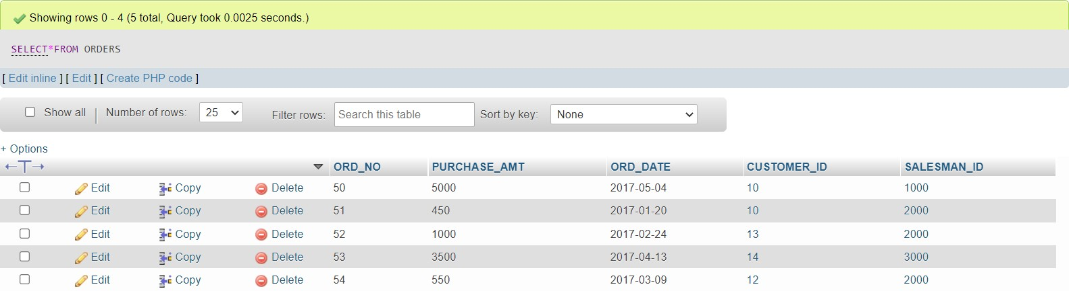

# Write SQL queries to

1. Count the customers with grades above Bangalore’s average.

**SELECT GRADE, COUNT (DISTINCT CUSTOMER_ID) FROM CUSTOMER**

**GROUP BY GRADE**

**HAVING GRADE> (SELECT AVG(GRADE) FROM CUSTOMER**

**WHERE CITY='BANGALORE');**

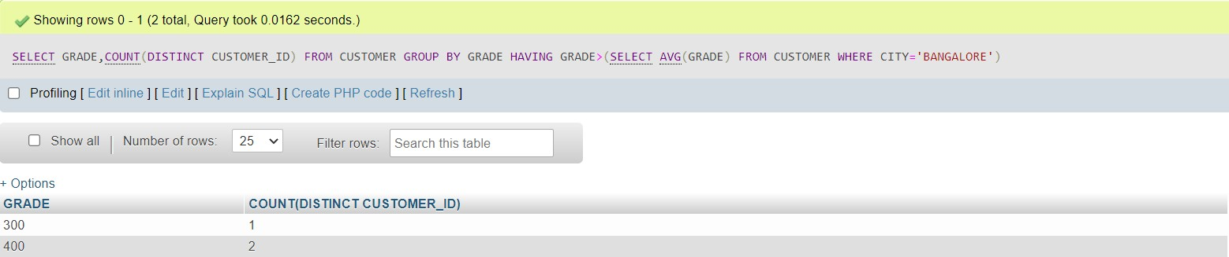

# Find the name and numbers of all salesmen who had more than one customer.

**SELECT SALESMAN_ID, NAME FROM SALESMAN S**

**WHERE (SELECT COUNT (*) FROM CUSTOMER C**

**WHERE C. SALESMAN_ID=S.SALESMAN_ID) > 1;**

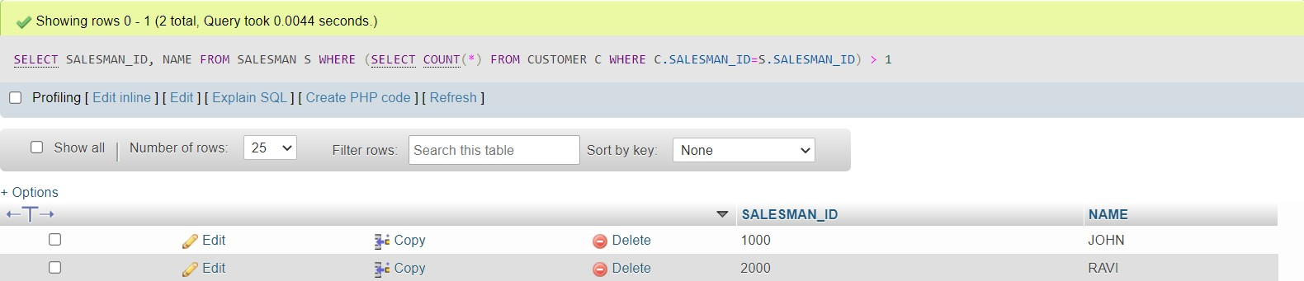

# List all salesmen and indicate those who have and don’t have customers in their cities (Use UNION operation.)

**SELECT S.SALESMAN_ID, S.NAME, C.CUST_NAME, S.COMMISSION FROM SALESMAN S, CUSTOMER C**

**WHERE S.CITY=C.CITY UNION**

**SELECT S.SALESMAN_ID,S.NAME,'NO MATCH',S.COMMISSION FROM SALESMAN S**

**WHERE CITY NOT IN (SELECT CITY**

**FROM CUSTOMER) ORDER BY 1 ASC;**

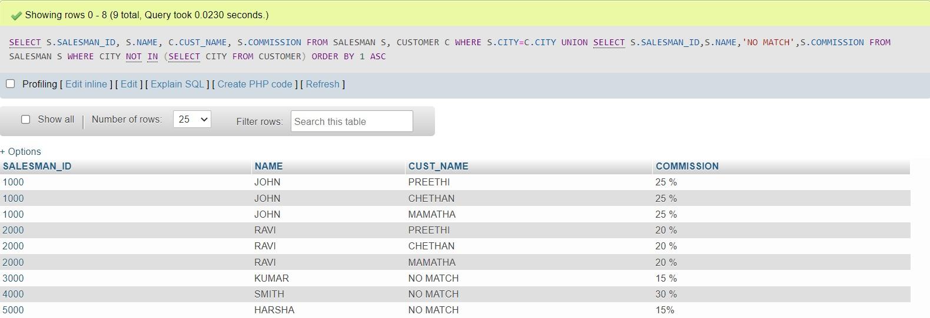

# Create a view that finds the salesman who has the customer with the highest order of a day.

**CREATE VIEW V_SALESMAN AS SELECT O.ORDER_DATE, S.SALESMAN_ID, S.NAME FROM SALESMAN S,ORDERS O WHERE S.SALESMAN_ID = O.SALESMAN_ID AND O.PURCHASE_AMOUNT= (SELECT MAX(PURCHASE_AMOUNT) FROM ORDERS C**

**WHERE C.ORDER_DATE=O.ORDER_DATE);**

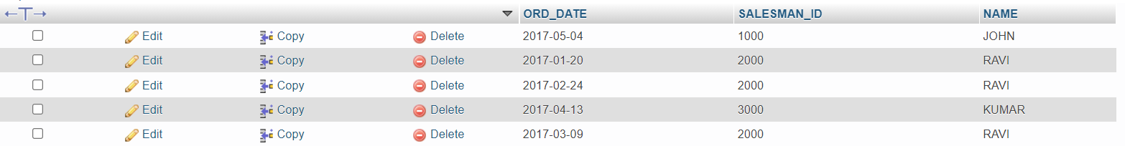

# Demonstrate the DELETE operation by removing salesman with id 1000. All his orders must also be deleted.

**DELETE FROM SALESMAN WHERE SALESMAN_ID=100;**